Isabelle Anno
Shanda Yaeger
SQL
10/20/2022
Locks Research Assignment
Isolation levels are a key concept to understand when there is more than one user of a database. Without them, things can get messy when two or more people are trying to access the same data at the same time. If this happens and you don’t have the correct isolation level, the wrong data can be read or modifications to data can be lost. Before we discuss the different isolation levels, let’s learn about the four major problems that make isolation levels necessary: dirty reads, non-repeatable reads, phantom reads and lost updates. Each of these problems involves TWO transactions happening at the same time on the same table by different users. We’re going to dive into each of these issues and why they happen, so we can then learn how to prevent them.
CUSTOMERS
First Name | Last Name
Sally | Smith
Jill | Johnson
Bob | Anderson
The first issue is called a “dirty read.” To understand this problem, let’s say we have a super simple CUSTOMERS table, with just the first and last names of each customer.

In this example, Sally just got married and needs to update her last name, so she goes into the database and changes her last name from “Smith” to “Miller.” As she’s doing this, before she commits the change, Jill hops on the database and wants to just read the CUSTOMERS table, so she does SELECT * FROM CUSTOMERS. The table pops up just like in the example above, but then Sally’s query commits right after, so Jill is reading an outdated table without realizing it. This is an example of a dirty read- it involves two transactions where one is modifying the table and the other is just reading it, so the reader gets an inaccurate, outdated table.
The second issue is a “non-repeatable read.” Dotnettutorials.com has a great definition of this problem- they say, “This problem occurs when one transaction reads the same data twice while another transaction updates that data in between the first and second read of the first transaction.” In this example, we own a hardware store. We want to look at the PRODUCTS table, but only the garden section, so we execute the query below:
SELECT * FROM PRODUCTS WHERE PRODUCT_TYPE = ‘Garden’

PRODUCTS
ProductID | Product_Name | Product_Type
1 | Outdoor chair | Garden
2 | 1kg Soil Bag | Garden
3 | Sunflower Seeds | Garden
The results appear below:
At the same time as we read the results of this query, someone else is updating this data. They want to move the outdoor chair into the “furniture” product type, so they execute the following query:

UPDATE PRODUCTS SET PRODUCT_TYPE = ‘Furniture’ WHERE PRODUCT_ID = 1
PRODUCTS
ProductID | Product_Name | Product_Type
2 | 1kg Soil Bag | Garden
3 | Sunflower Seeds | Garden
If you run the first query again (SELECT * FROM PRODUCTS WHERE PRODUCT_TYPE = ‘Garden’) you’ll get a table with one fewer row this time because Outdoor chair is no longer of product type Garden. Your table will look like this:

The fact that the two tables are different is confusing and causes a non-repeatable read because one user is updating data in between the time when the first and second SELECT queries are being executed, causing two different tables to form.
The third problem is a phantom read. As cool as the name sounds, it can also be quite confusing. A phantom read is similar to a non-repeatable read, only instead of the confusion being caused by the updating of existing data, it’s from inserting new data into the table. A simple example goes back to our products table. This time, instead of updating the product type of the chair, we will add a completely new product with a Garden product type in between the first and second reads. The result is shown below.
PRODUCTS
ProductID | Product_Name | Product_Type
1 | Outdoor chair | Garden
2 | 1kg Soil Bag | Garden
3 | Sunflower Seeds | Garden
First read:

An INSERT query is then performed between the first and second read:
INSERT ProductID, Product_Name, Product_Type INTO PRODUCTS VALUES (4, ‘Terracotta vase’, ‘Garden’);

PRODUCTS
ProductID | Product_Name | Product_Type
1 | Outdoor chair | Garden
2 | 1kg Soil Bag | Garden
3 | Sunflower Seeds | Garden
4 | Terracotta vase | Garden
Second read:
You can see how the two concepts are similar and how both can easily cause confusion due to a different number of rows being seen the first and second times we read the data.

The last problem is the Lost Update. Lost updates are fairly rare, but when they do happen they can be pretty devastating to the data in a database. Essentially, this is where two transactions read and update the same exact column on the same row of the same table at the same time. The data from the second transaction is lost because it was overwritten by the first transaction. The photo below shows an example of this type of problem- please note I do not take credit for this, this photo was from sqlskull.com (Exact source cited at the end.)
. 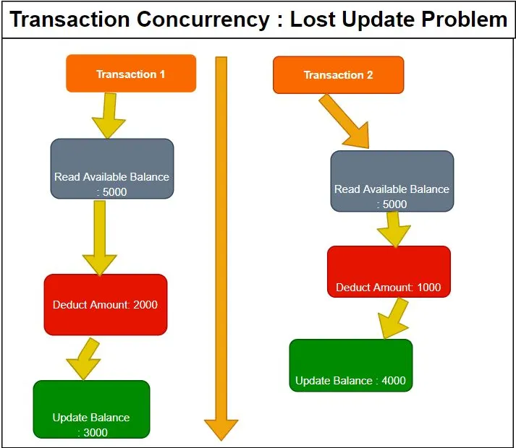
Now that all four problems are clearly defined, we can get into the four isolation levels- read committed, read uncommitted, repeatable read, and serialize. Isolation levels solve these four problems by creating different types of locks, or rules that control what you can or cannot do depending on what the other user is doing. If everyone is just SELECTing and reading data, that is allowed. But if two people are modifying data, one must wait for the other to finish before they can modify theirs, otherwise these issues arise.
The default isolation level is called READ COMMITTED. This creates locks for transactions that are freed as soon as each segment of the transaction is completed. SQL Server doesn’t wait until the end of the entire transaction- just until the end of each “part” of the transaction. If you wrote a transaction that SELECTS three things, UPDATEs two and DELETEs one, READ COMMITTED will free the locks associated with the SELECTs first, then the UPDATEs and then the DELETEs as they are executed, so that by the time the transaction is done, all three “parts” of it were unlocked. This prevents dirty reads, but the other three problems can still occur.
The next isolation level is READ UNCOMMITTED. It’s risky because it doesn’t set any locks or follow any other locks that were set. You can experience any of the four concurrency issues with it, but it is speedy,
The third isolation level is a REPEATABLE READ. In this isolation level, new rows can be inserted into the database, but you cannot update or delete data until the transaction is complete. It slows things down quite a bit, but it prevents dirty reads and non-repeatable reads.
Lastly, we have SERIALIZE. This one prevents all forms of concurrency issues except for a lost update. It prevents other transactions from changing data that is being modified by the current transaction- it basically puts all transactions on hold until this one is done. You cannot insert, update or delete anything until this transaction is complete. This hinders productivity because other users must wait for your transaction to be done before they can modify anything. Most of the time, we just stick to the default unless we have a good reason not to.
In this research paper, we discussed the four common concurrency problems when using a database- dirty reads, non-repeatable reads, phantom reads and lost updates. We then discussed the four isolation levels that help us combat these issues. All four have their pros and cons, but most of the time we use the default READ COMMITTED, unless it’s likely we’ll encounter a concurrency problem. This has been an excellent way to learn about this topic.

Sources
Researching the four problems:
https://www.youtube.com/watch?v=x-BSUxvjVOo
https://dotnettutorials.net/lesson/non-repeatable-read-concurrency-problem/#:~:text=The%20Non-Repeatable%20Read%20happens%20in%20SQL%20Server%20when,understand%20the%20Non-Repeatable%20Read%20Problem%20with%20an%20example.
https://sqlskull.com/2021/06/27/lost-update-problem-in-concurrent-transations/#:~:text=SQL%20Advance%20A%20lost%20update%20problem%20occurs%20in,row%20within%20a%20database%20at%20the%20same%20time.
Researching isolation levels:
https://www.mssqltips.com/sqlservertip/4438/compare-repeatable-read-and-serializable-sql-server-transaction-isolation-levels/
Week 8 PowerPoint- Locks in SQL Server Powerpoint in materials folder

